LAB 11: Emitter Bias & Collector Feedback Biasing

**Date: Reg.#:**

## OBJECTIVES:

* To implement the emitter bias scheme for the common emitter bipolar junction transistor.
* To implement the collector feedback biasing scheme for the common emitter bipolar junction transistor.

## SUGGESTED READING:

* Class Lectures
* [Chapter 7: “***Bipolar Junction Transistors***”, *introductory Electronic Devices and Circuits by Robert T. Paynter.*](http://arduino.cc/en/Guide/HomePage)
* Datasheet: 2N3904 NPN bipolar Junction Transistor

## EQUIPMENT AND COMPONENTS:

* Basic Circuits Training Board
* 2N3904 Transistor
* Jumper Wires
* Scope / DMM
* Resistors
* DC Power Supply

---------------------------------------------------------------------------------------------------------------------

## Emitter bias common emitter BJT

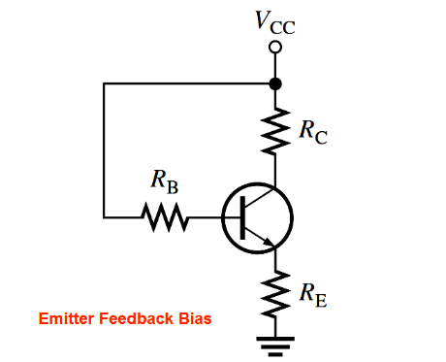If an emitter resistor is added from the emitter to ground in the fixed bias circuit of common emitter BJT, the new circuit is called as emitter biased common emitter amplifier, as shown in the figure. The idea is to help make base bias more predictable with negative feedback, which negates any attempted change in collector current with an opposing change in base voltage. If the collector current tries to increase, the emitter voltage increases, causing an increase in base voltage because VB = VE + VBE.

This increase in base voltage reduces the voltage across RB, thus reducing the base current and keeping the collector current from increasing. A similar action occurs if the collector current tries to decrease. While this is better for linear circuits than base bias, it is still dependent on βDC and is not as predictable as voltage-divider bias.

*Fig. Emitter bias common emitter BJT*

## Input and output current

The input current can be obtained by applying KVL to the input side. Applying the KVL to input gives the following equation.

From this equation, the input current can be calculated as

As the output current is related by the following expression

where is the current amplification factor.

The emitter current can be found by adding the base current and the collector current.

## Input and output voltage

The input voltage is base-emitter voltage which is approximately for silicon transistor. The output voltage can be calculated by applying KVL to the output side of the circuit diagram.

$$V_{CE}-V_{CC}+I_{C}R_{C}+I_{E}R_{E}=0$$

$$V_{CE}=V_{CC}-I_{C}R_{C}-I_{E}R_{E}$$

The output voltage can be simply be interpreted as the voltage equal to the supply voltage Vcc minus the voltage that has dropped across the external bias collector resistance Rc & emitter resistance RE.

## Collector feedback biasing common emitter BJT

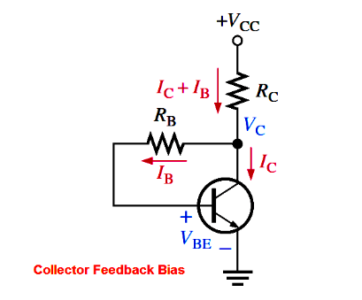In this type of biasing the base resistor RB is connected to the collector rather than to VCC. The collector voltage provides the bias for the base-emitter junction. The negative feedback creates an “offsetting” effect that tends to keep the Q-point stable. If IC tries to increase, it drops more voltage across RC, thereby causing VC to decrease. When VC decreases, there is a decrease in voltage across RB, which decreases IB. The decrease in IB produces less IC which, in turn, drops less voltage across RC and thus offsets the decrease in VC.

## Input and output current

*Fig. Collector feedback biasing common emitter BJT*

In the above figure, the current designated as *I* flowing through collector resistance is the sum of the base current and collector current i.e. ${I=I}_{C}+I_{B}$.

The input current can be obtained by applying KVL to the input side. Applying the KVL to input gives the following equation.

From this equation, the input current can be calculated as

As the output current is related by the following expression

where is the current amplification factor.

The emitter current can be found by adding the base current and the collector current.

## Input and output voltage

The input voltage is base-emitter voltage which is approximately for silicon transistor. The output voltage can be calculated by applying KVL to the output side of the circuit diagram.

$$V_{CE}-V_{CC}+IR_{C}=0$$

$$V_{CE}=V_{CC}-{(I}_{C}+I_{B})R_{C}$$

where ${I=I}_{C}+I_{B}$.

The output voltage can be simply be interpreted as the voltage equal to the supply voltage Vcc minus the voltage that has dropped across the external bias collector resistance Rc.

## Procedure

* Connect the circuit as shown in the diagram and set the supply voltage Vcc.
* Measure the input current (base current), emitter current and the output current (collector current) with the help of an ammeter and record the reading in the table.
* Measure the output voltage VCE with a voltmeter and record the value in the table.

## Observations

**Emitter Feedback Biasing**

**Simulation and results:**

$V_{cc}=$_________, Rc = __________, RB = __________, β = ___________, R E = ___________

|  |  |  |  |
| --- | --- | --- | --- |
|  | Calculated | Measured in Simulink | Measured in Lab |
| Input current (IB) |  |  |  |
| Output current (IC) |  |  |  |
| Emitter current (IE) |  |  |  |
| Output voltage (VCE) |  |  |  |

**Collector Feedback Biasing**

$V_{cc}=$_________, Rc = __________, RB = __________, β = ___________

**Simulation and results:**

|  |  |  |  |
| --- | --- | --- | --- |
|  | Calculated | Measured in Simulink | Measured in Lab |
| Emitter current ($I=I_{E}$) |  |  |  |
| Base current (IB) |  |  |  |
| Collector current (IC) |  |  |  |
| Output voltage (VCE) |  |  |  |

## Tasks

* Perform all the calculations for the base current, emitter current, collector current and output voltage on separate pages.

# REVIEW QUESTIONS:

Q: Name all the biasing techniques for the common emitter BJT that you have implemented in the lab?

Q: What is the difference between all the biasing techniques for the CE BJT that you have studied in the lab?

Q: How the emitter bias and collector feedback biasing CE BJT are insensitive or independent of the $β$ variations?